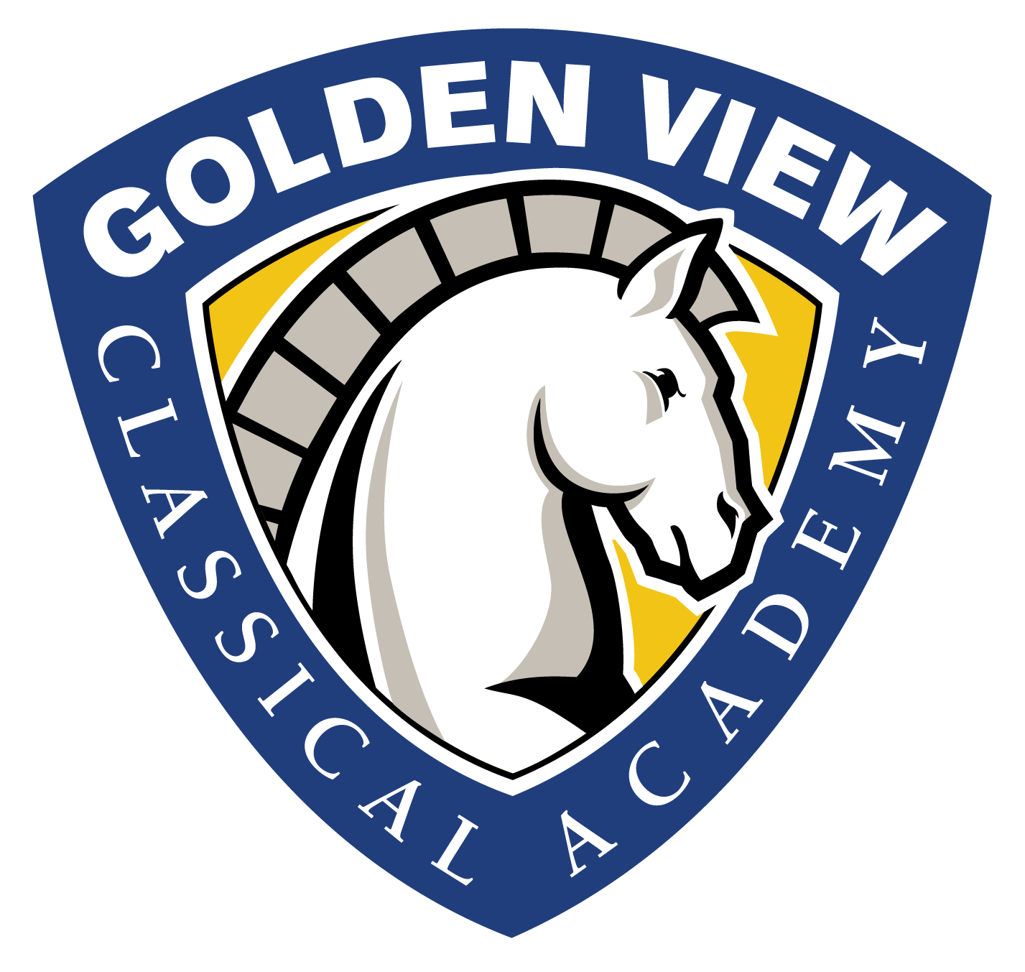
FY 20
Salary Schedule and Policy
Salaries at Golden View Classical Academy are not established pursuant to C.R.S. §22-32-109.4 or 22-63-401.

The School establishes teacher and administrative salaries individually, based on an employee’s job duties, experience, qualifications, needs, and performance, as well as comparison to salaries for comparable positions in other schools or districts, and defines those salaries through individual contracts of employment.

The school’s current pay scale is in the range of $42,000-$54,560 for full-time teaching positions. Administrative salaries range from
$32,000 -$125,000.

